Navigate the Money Maze
Booking Form
(Funded Courses)

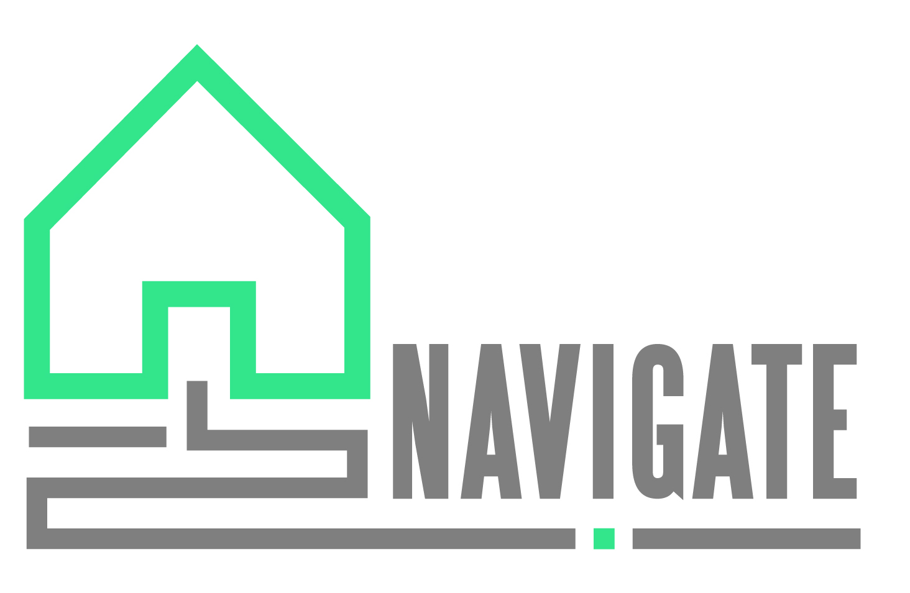
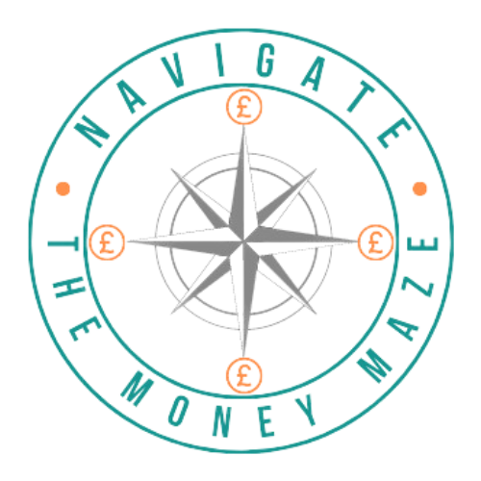
General Terms and Conditions

- Please complete the booking form, for any queries please contact ntmm@navigatecharity.org.uk

- The minimum/maximum numbers of attendees are:
a. Face to Face courses and workshops – Minimum 4, Maximum 12
b. Online courses and workshops – Minimum 4, Maximum 15

- As the organising agency/organisation, you are responsible for ensuring participants are booked onto the course and meet the minimum attendee numbers.

- All correspondence will be sent to the named contact on the booking form.

- We will make every effort to accommodate special requirements, these should be notified at least 7 days prior to the course/workshop date.

- We will endeavour to send all pre-course information to participants 7 days before the course/workshop.

- All personal data and information relating to attendees will only be used in accordance with our privacy notice which can be found on our website www.navigatecharity.org.uk or by emailing ntmm@navigatecharity.org.uk

- Navigate CIO owns all materials, design, development, product and service information for financial education courses/workshops. It cannot be used by any other party without express consent of Navigate.

Cancellation and Alteration

- We reserve the right to cancel a course/workshop if minimum numbers are not met.

- We reserve the right to alter the programme or trainers without prior notice.

- In the event of a course being cancelled the organisers and participants will be notified as soon as possible.

- We require a minimum of 7 days’ notice, in writing, for cancellation.

- Cancellations made 1-6 days prior to the course date will be charged a set fee of £50.

About you and your organisation
Your Name
Job Title
Contact Number
Email Address
Organisation name
Name & Address for Invoicing in the event of course cancellation <7 days
Organisation type | Voluntary Sector | ☐
 | Private Sector | ☐
 | Education | ☐
 | Other, Please Specify | ☐

Target Audience
Staff | ☐
Clients | ☐
Volunteers | ☐
Students | ☐
Other, please specify …………………………………………………………………………… | ☐

Location (District)
Mendip | ☐
Mid Devon | ☐
North Devon | ☐
Sedgemoor | ☐
Somerset West & Taunton | ☐
South Somerset | ☐
Torridge | ☐
West Devon | ☐
Other, please specify …………………………………………………………………………… | ☐

About the Course/Workshop
Total number of courses required
First course/workshop date
Second Course/Workshop Date
Third Course/Workshop Date
Course/Workshop Venue
Duration of course/workshop | 1 Hour | ☐
 | 2-3 Hours | ☐
 | 6 Hours | ☐
Delivery Method | Face to Face | ☐
 | Online | ☐
Number of Participants
Course/workshop topic
Budgeting |  | ☐
Making Financial Decisions |  | ☐
Benefits |  | ☐
Life Skills - Job Search |  | ☐
Debt Awareness Training |  | ☐
Financial Products and Services |  | ☐
Non-nationals - Living in the UK |  | ☐
Students: Money matters: financial budgeting and savings options |  | ☐
Students: Money matters: financial risks and debt |  | ☐
Other, Please Specify……………………………………………………………………………………………………… |  | ☐

How did you hear about Navigate?
At an event | ☐
Advert | ☐
Social Media | ☐
Online Search | ☐
Recommended by agency/organisation | ☐
Other, please specify….. | ☐

Please provide any other special requirements/information here.

Declaration
I confirm information provided is correct and accurate to the best of my knowledge |  | ☐
I have read and agreed to the Booking Terms and Conditions |  | ☐
Print Name
Signature

Date

For Internal Use Only
Course Delivery Information
Navigate Contact (booked by)
Course/Workshop Topic/Module
Funder
Total Number of Courses
Course Duration
Course Date(s)
Delivery Method
Lead Tutor Name
Support Tutor Name
Start Time of Course
End Time of Course
Venue Address

Parking and Access information

Venue Providing Equipment / Refreshments | Projector | ☐
 | Flip Chart & Pens | ☐
 | Flipchart Paper | ☐
 | Tea, Coffee & Water | ☐

Any other relevant information

